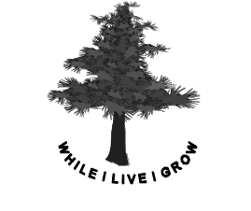
Sheikh Mandah, Airport Road, QUETTA. Phone: 081-881101-3 Fax: 081-2881103 wilderness@wilderness.edu.pk

Wilderness School & College

ADMISSION FORM - 2013
Please complete the following in block letters

Student’s Full Name:

Date of Birth:

Level of Admission:

Gender:
Male: Female:

Previous School:

PERSONAL INFORMATION REGARDING CHILD:
(Special health/emotional conditions, allergies, weaknesses, etc., etc.)

Father’s Name:

Father’s Occupation:

Phone Number:
Office: Mobile:

Mother’s Name:

Phone Number: Office: Mobile:

Residential Address:

Phone Number: Res.:

Children already studding in this school (Please give names & classes)

Date:

Parent’s Signature

FOR OFFICE USE
ADMISSION NO.
BOOK NO.
ADMISSION DATE

CLASS SECTION

PRINCIPAL
ACCOUNTANT
ERO

PARENTAL AGREEMENT

Upon admission of my son/daughter ________________________________ to Wilderness School I agree to the following:

- To participate actively and positively with the school staff in providing the best possible educational support to my child.
- To attend all parent meetings and school activities.
- To pay the school fee by 10th of the first month in each bi-monthly period. A late fee of Rs. 200 per month is payable after this date. (Persistent non-payment may result in cancellation of admission).
- To provide written explanation of all absences from school even if telephonic intimation of absence has been given.
- To ensure that school attendance is punctual and regular. Commencing the term late or leaving the term early for vacation purposes is unacceptable.
- To assist the child in acquiring functional English language skills in the home.
- To forward at least one month’s notice of intention to withdraw the child from the school.
- To accept the need for an annual fee increase related to the ever-escalating “cost-of-living” as imposed by government.

CERTIFICATE FROM THE PARENT

- Certified that the date of birth given above is correct to the best of
my knowledge and belief and is in accordance with that given in Horoscope, Municipal corporation or school records.
2. I have the rules about payment of fees and blind myself to them.
3. Choice of elective subject shall be determined by the Principal.

NOTE: All school matters, related to the student, will be discussed ONLY with the child’s parents.

MOTHER: FATHER:
Date: Date:

UNDERTAKING

As a parent/guardian I fully undertake the responsibility of the conduct and behavior
of my son/daughter _____________________________ of class ________________. I assure you that he she will comply with all the rules and regulations of school and of those standing orders which are issued time by time. He/She will not be involved in any mal practice, cheating, fighting and using abusing language. He/She will give full energies to show reasonable improvement in current results and towards studies. In case of any violation his/her admission in school my be reviewed at any time.

_____________________ ___________________
Parent/Guardian Date

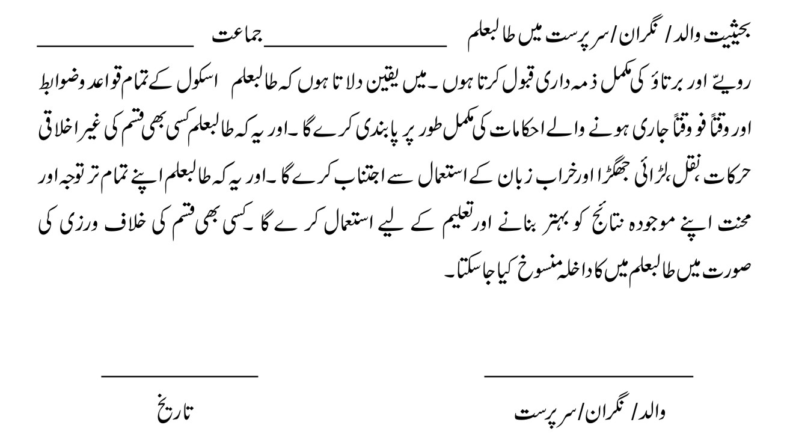

Principal,
Wilderness School,
Quetta.
Date : __________________

FIELD TRIP PERMISSION SLIP

I hereby give permission for my son/daughter ___________________________________
Of class _____________________ to attend all field trips, excursions and out of school activities.
Whereas I understand that the school authorities will take all due care for the security and safely of the student I accept full responsibility for the welfare of my son/daughter.

Signed: ________________
Parent/Guardian

WILDERNESS SCHOOL
Admission / Withdrawal Slip

Please add/delete the student’s Name _______________________________________________

S/o, D/o ____________________________________ Admission No. _____________________

Date of Birth __________________ Class ________________ Section _____________________

Phone No.: Residence _______________________ Office _______________________________

Mobile No.: _____________________________ Admission / Withdrawal Date _______________

_________________ ____________________
Section Head Accountant

_________________ ____________________
Class Teacher FDO

